CARBOHYDRATES
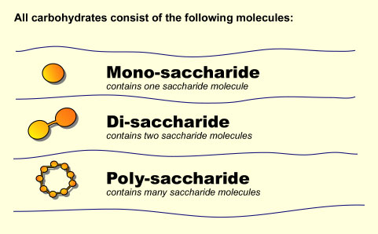
There are 3 categories of Carbohydrates
- ________________
- ________________
- ________________

Functional Properties of Starch
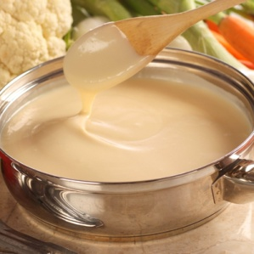
Gelatinisation
Pg 93 Food Tech in Action
Starch is a ______________ and found in grains such as rice, wheat and vegetables such as cassava and potatoes.
Gelatinisation is defined as: ______________________________________________________________
This process takes place regardless of the type of ________. The physical qualities of the gel produced, however, are determined by the ratio of _____________ to _________________ and the method used to prepare the food.
What are the three most common ingredients used to thicken liquids in a domestic kitchen?

Which starch is used in the hospitality industry to thicken liquids and why?

Factors that affect gelatinisation of starch
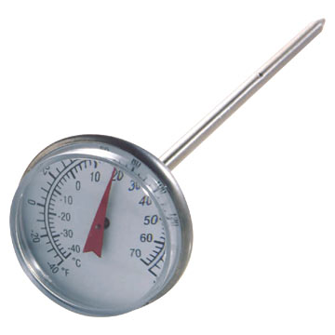
The functional properties of carbohydrates are affected by changes in temperature, pH, agitation and the presence of other ingredients
Temperature
Gelatinisation requires _____________________________. Starch is not soluble in cold water therefore cannot __________________________. To absorb liquid the outside of the starch granule needs to be softened by heating it to ________C, this allows it to ____________________________. At 86-90C the swollen starch granules burst and the amylose and amylopectin they contain are released, capturing the liquid and ______________________________________________________.
What will happen if the mixture is not boiled for 1 minute before serving?

How should the sauce look if it is successfully gelatinised?

When a gelatinised mixture cools, it forms a more rigid _____. Some cold gels such as custard made from custard powder, rupture and ‘weep’ liquid when _____ or ________.What happens when gels are reheated? ______________________________________________________________________
What is a roux?

Agitation
Agitation is essential for the creation of a smooth, gelatinised sauce. Gelatinisation takes place within a specific temperature range in the presence of liquids. What happens if only some of the starch granules are exposed to the liquid? _______________________________________________

How can you prevent lumps forming in a sauce thickened with starch?
- ___________________________________________________________________________
- ___________________________________________________________________________
- ___________________________________________________________________________
- ___________________________________________________________________________
Starch is ______________ in cold water

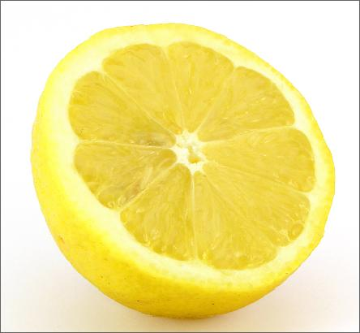
The impact of other ingredients and pH
The gelatinisation process can be affected by several additives, particularly sugar and acid.
_________ competes with ________ for water, so not as much water is available for the starch to absorb. Sugar _________ the temperature at which the starch granules start gelatinising, making the mixture more liquid and less likely to remain ________.
What affect does acid have on starch mixtures?

What are the important features of a roux?

What effect does sugar have on a starch mixture?

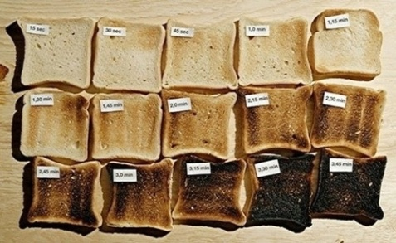
Dextrinisation
Pg 94 Food Tech in Action
Dextrinisation is defined as:

One of the most common examples is:

The polysaccharide starch can undergo a partial chemical breakdown into shorter glucose chains called _____________.
Dextrins are the halfway point in the complete breakdown of a starch molecule into the monosaccharide glucose. Complete the table below to show this process
Starch |  |  | Glucose
 |  | (disaccharide)

List the differences between dextrins and starch:
- ___________________________________________________________________________
- ___________________________________________________________________________
- ___________________________________________________________________________
Dextrinisation can be caused by:
- ___________________________________________________________________________
- ___________________________________________________________________________
- ___________________________________________________________________________

Dextrinisation is the reason for:
- Gravies being brown
- Bread turning brown when toasted
- Toasted commercial breakfast cereals being brown and sweeter than raw cereals
- The brown crust forming on baked starchy vegetables such as potatoes and carrots
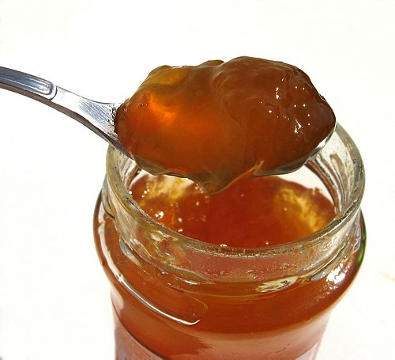
Functional Property of Pectin
Pg 94 Food Tech in Action
Pectin is a polysaccharide found in the liquid extract of many fleshy fruits, it is responsible for:

Fruits high in pectin include:

What must be present for pectin to gel? ______________
When making jams the pectin dissolves in water and the sugar and boiling process reduces the liquid and a gel results on cooling.
Functional Properties of Sucrose
Crystallisation
Pg 95 Food Tech in Action
Crystallisation is a functional property of sugar related to its ability to ___________ and reform crystals. Sucrose which is derived from cane sugar is easily dissolved in water. Where is this property used? ____________________________________________________________________________
How does this process occur?

The four factors that affect the crystallisation process can be summarised as follows:
- Temperature: The _________the temperature is, the __________ the number of crystals that will form, hence the greater solidity of the final product
- Acidity: Disaccharides are formed when two monosaccharide’s chemically join to create a new sugar molecule. Acid such as ____________ splits the bond joining the disaccharide, creating separate monosaccharide’s which crystallise less readily than disaccharides and so inhibit the development of large crystals in a solution, this gives the confectionary a ___________ texture
- Agitation: Stirring sugar solutions _____________ crystals to develop. If a solution is stirred while hot, crystallisation starts too soon, giving the product a ___________ texture. It is essential that a sugar is stirred into a liquid and fully dissolved before the mixture boils. Stirring after boiling point is reached __________ crystals to form
- Presence of other ingredients such as _________, ___________________ and __________.
Caramelisation
Pg 96 Food Tech in Action
Sucrose melts at_______. Above that temperature, acids form and the molten sugar turns a light ________, or caramelises which adds flavour to foods. If the heat is not removed, the liquid sugar becomes darker and darker until it is black. This process happens without water as it has been evaporated during the cooking process.

Summary

