Gelation
Pg 88 Food Tech in Action

Gelation is the process of_____________________
How does the Gelation of Proteins occur?

Give 3 examples of foods produced through Protein Gelation

List the 3 factors necessary for the formation of these gels

Gelation occurs more quickly if both the pH and temperature of the mixture are:
(circle the correct answer)
High Medium Low

What is the difference between Gelation and Gelatinisation? Give examples of foods where these properties occur

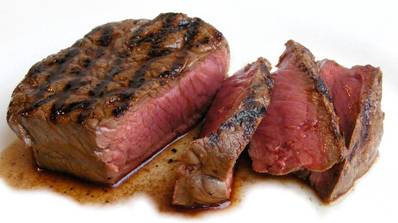
Browning
Pg 91 Food Tech in Action

List the 3 reasons that foods containing
protein turn brown

Oxidative browning of red meat
Myoglobin and haemoglobin are the proteins that give red meat its _________________________
Myoglobin also causes_______________________________________________________________

Complete the table below on the process of oxidative browning by filling in the spaces
Protein |  | Oxymyoglobin
Colour |  |  | Brown

What factors speed up oxidative browning?

What can you do to reduce oxidative browning of meat?

Would you buy red meat that has turned brown on the surface? Explain why or why not

Non-enzymic browning of red meat
What must be applied during non-enzymic browning? ______________
Is oxygen involved in non-enzymic browning? ____________
Explain why when cooking meat it can be brown on the outside and pink on the inside

What must happen to meat for it to be described as ‘well done’?

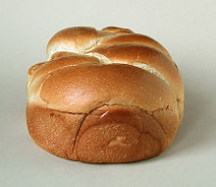
Maillard reaction
When does the Maillard reaction take place?

What are the main effects the Maillard reaction has on food?

Explain why moist-heat cooking methods (steaming, boiling) do not produce the Maillard reaction?

What could happen if you stored a food containing both protein and sugar above room temperature?

